AM2000-Asia-China-Song-Jiangsu-Xanadu-1279 CE

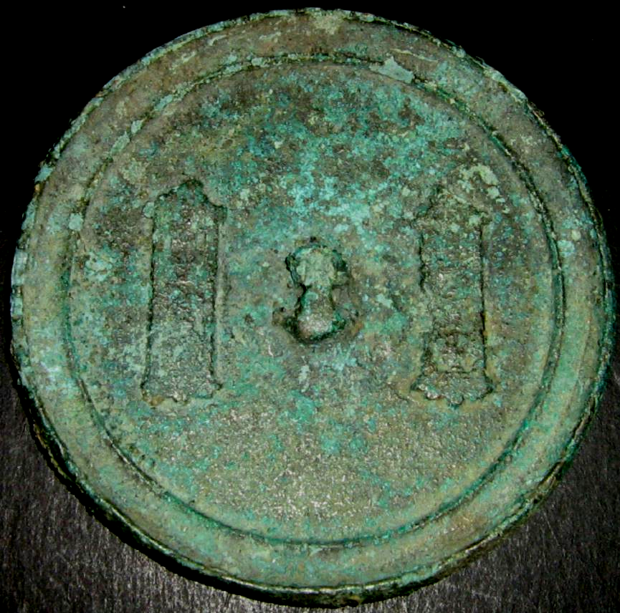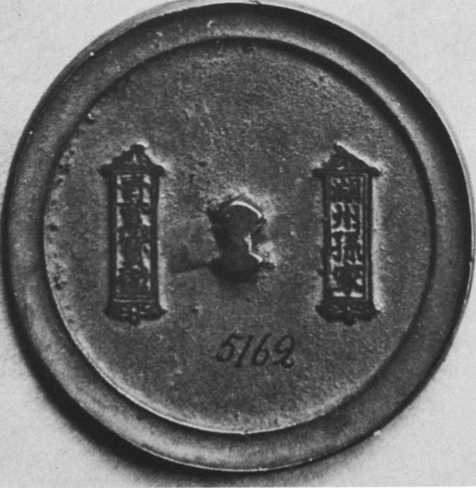

**Left: Mirror found in Inner Mongolia, 275 km (171 mi) north of Beijing, in the Minusinsk Basin, Xanadu-1279 CE (*Atlantica Coll.*), Right: Mirror with inscription, Diam. 8 cm. 12th-13th c. CE. (*Minusinsk Museum)*.**

Case No.:

Accession Number: AM2000

Formal Label: **Asia-China-Song-Jiangsu-Xanadu-1279 CE**

**Display Description:**

Southern Song Dynasty Mirror from Xanadu, ca. 1279 CE

This Southern Song (南宋, 1127–1279) bronze mirror has an interesting story because it reflects the takeover of China by Kublai Khan, the first non-Chinese Emperor.

The mirror was cast in Xuzhou (徐州) a major city in Jiangsu province on the Huai Ho (WG) in east-central China that drains the plain between the Huang He (WG, Yellow River) and the Yangtze River. However, it was found in the Minusinsk Basin, which was then the Mongol stronghold of Kublai Khan. How did this mirror come to reside with the Mongols?

The answer is partly due to the climatic situation in 1279 CE and partly due to the political turn of events. The Huai Ho river was subject to seasonal flooding which was exacerbated due to an increase in rainfall and a lengthened growing season. As a consequence, the population expanded. Simultaneously the increased rainfall flooded the Huang Ho river and it changed its course which diverted it into the lower Huai Ho valley near Xuzhou. The land in which the Huai Ho flowed now became barren.

Concurrently, the Jin Dynasty to the north also experienced a population explosion and took control of northern China. Close on the heels of the Jin were the Mongols under Möngke Khan (1209 –1259) who conquered the Jin and took control of northern China in 1234. When Möngke Khan died, his younger brother, Kublai Khan (1215-1294), who was also the grandson of Genghis Khan, succeeded him. In 1271 Kublai Khan was proclaimed the Emperor of China.

When the Southern Song Dynasty was conquered by Kublai Khan in 1279 prestige goods flowed north to Kublai Khan's capital, Xanadu. It is possible that this mirror was part of these prestige goods acquired by Kublai Khan and his Kahnate since it was found in what is now Inner Mongolia, 275 km (171 mi) north of Beijing. If so, his mirror attests to Kublai Khan's appreciation of key treasures of the Southern Song Dynasty to enhance his court.

The mirror displays typical signs of Southern Song mirrors of the 12th to 13th centuries CE: it is thin with a raised border, and is without designs except for two vertical inscriptions placed within in two frames. A near duplicate of this mirror is now in the Minusinsk Museum.

LC Classification:

Date or Time Horizon: 1279 CE

Geographical Area: **Xuzhou (徐州) a major city in Jiangsu**

Map:

GPS Coordinates: [34°16′N 117°13′E](https://tools.wmflabs.org/geohack/geohack.php?pagename=Xuzhou&params=34.26_N_117.21_E_type:adm2nd_region:CN-32)

Cultural Affiliation:

Medium:

**Dimensions**:   
**Weight:**

**Provenance**:

**Condition:**

**Discussion:**

**References**

Wang Shih-lun, "T'an-t'an Hu-chou ching,"  *Wenwu,* 1958, no.6

E. Loubo-Lesnitchenko, Imported Mirrors in the Minusinsk Basin, Artibus Asiae, Vol. 35, No. 1/2 (1973), pp. 25-61.